Accessing Wolf Time Training for Leave Coordinators
When a new leave coordinator starts in a county either due to a new hire or a promotion, they must go through the Wolf Time training and test before they will receive access. Here are the steps needed to take to access the training:
1. Navigate to https://hr.ncsu.edu/wolftime/
2. Click on Resources:
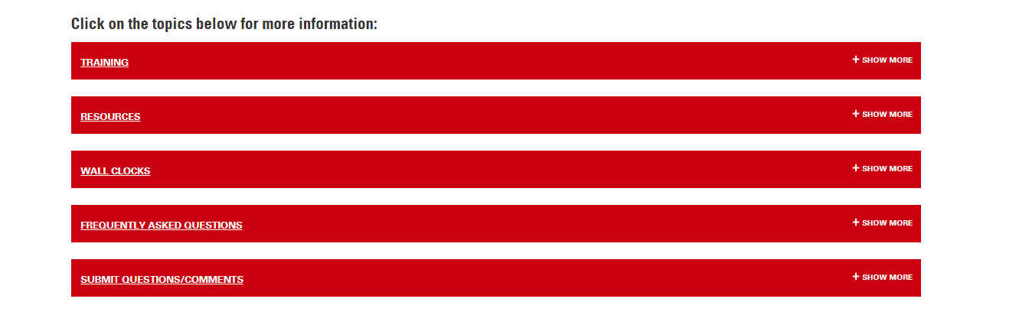
3. Click on Leave Coordinator Videos:
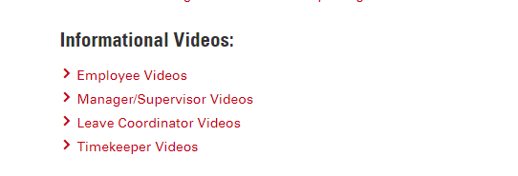

4. A new window will open asking you to log in with their Unity ID and password. Click Log in:
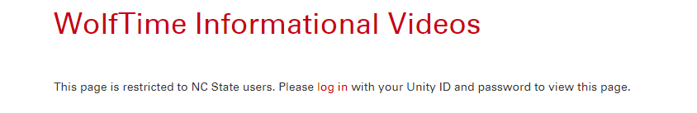
5. The next screen will be like this, click the red block:
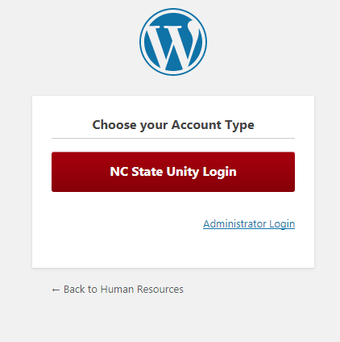

6. Next is the Shibboleth Login page:
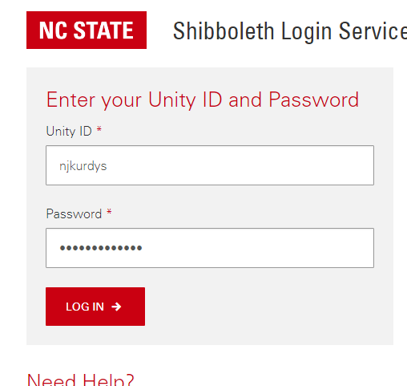

7. On the next page scroll down to the section that says Leave Coordinator Videos and click on the link that says “Register for the Leave Coordinator Mandatory Training course”:
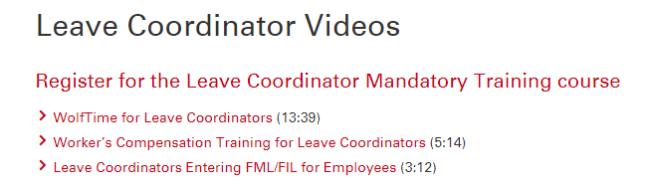

8. The system will now direct you to the Reporter system, click Add to Cart:
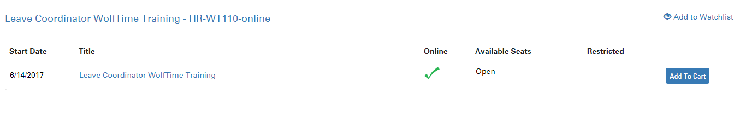

9. From here, follow the links as if you are purchasing the training. There is no cost but you will have to move through this process.
10. After you finish your enrollment you will receive an email from the Moodle Administrator where you can link to the training material. Follow the link to your course.
11. You will have to watch all of the Leave Coordinator videos. Make sure you watch somewhere that is free from distractions as you will be required to take a test.
12. When you finish all of the videos, click on the test on the right hand side of the page. You must score at least 75% to pass.
13. Once you pass your test, notify your District Administrative Assistant so they can request your system access.

