Cancelling Absence Requests
In Wolf Time, employees and supervisors both have the ability to cancel a leave request. If the employee cancels the request, the supervisor will receive the following email:
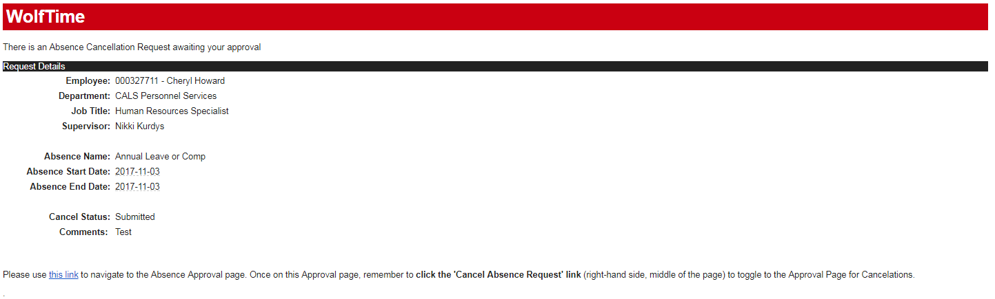
Supervisors can click on the blue link in the email to get to the page where they can “Approve” the cancellation request. Once the page opens you’ll need to click the blue link that says “Cancel Absence Request”. This will open a new page where any pending cancellations will show. Click on the one you want to approve then click submit.
