Clearing Exception Alarms

Step 1: Navigate to the “For Managers” tab in the MyPack Portal

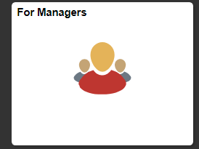

Step 2: In the “My Employees Time” section click on “Time Exceptions”
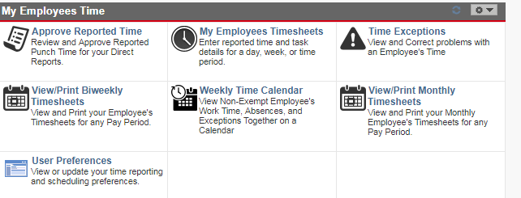

Step 3: Your page might automatically show you who has exceptions in your county, mine does not because I have different access. If you see listings click on the name of the person you need to correct. If not, you’ll need to search by putting the employee’s last name in the Employee Selection Criteria and clicking on “Get Employees”.
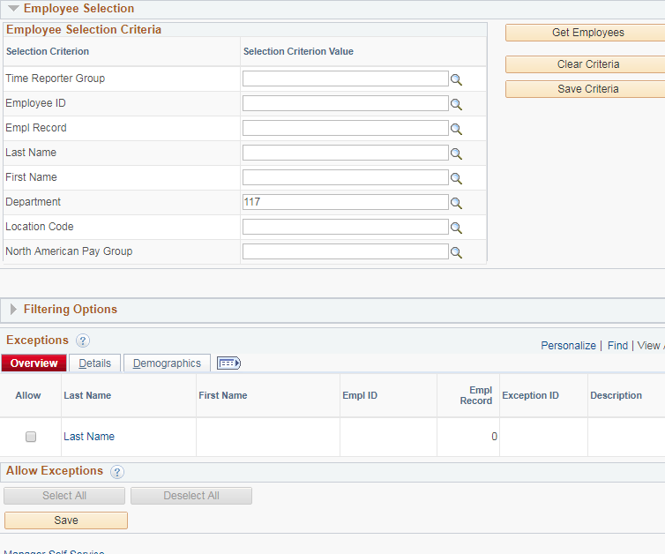

Step 4: When the time sheet opens find the row that has the Exception Alarm. You will need to look at the row with the alarm and the other rows around it as it could be a previous day that caused an alarm. In this example, you will see several days the problem started on June 7th when the employee didn’t clock out. Make any necessary changes, then click “Submit”.
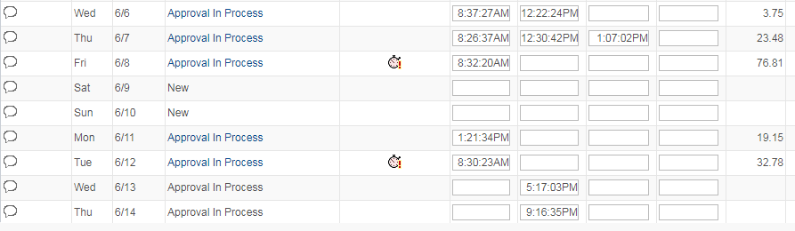

Step 5: Click on the “Exceptions” tab in the section below the time sheet. Put comments in next to each row then click the “Update Exception” button. The alarms will not clear right away but they will clear after the next time administration run.

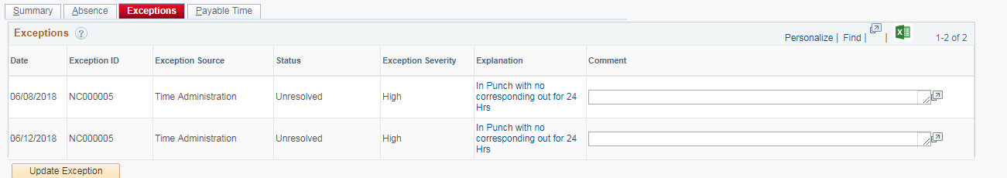

Step 6: Approve any rows that were changed.

