Mobile Override Instructions
In order to quickly access the Employee Self Service section of the MyPack Portal on a mobile device, you’ll need to set up your access. Start by logging onto the MyPack Portal and navigate to Employee Self Service. Once in Employee Self Service you will see a page similar to the one below:
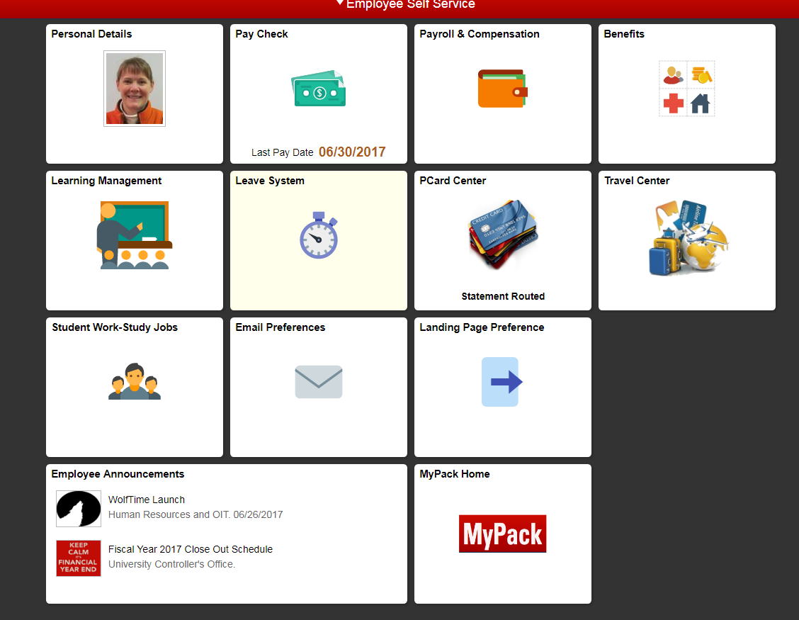
Click on the tile that says “Landing Page Preference” and you will see:
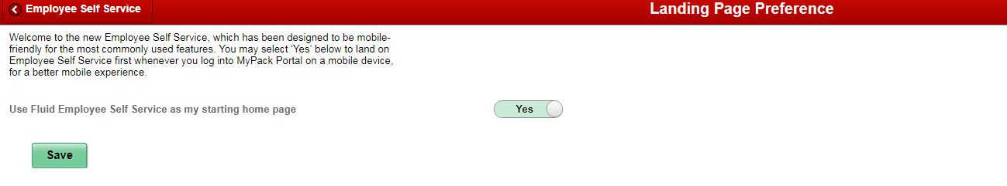
Make sure the “Use Fluid Employee Self Service as my starting home page” is set to Yes, then click save. Now when you log onto the portal using your mobile device you will be taken directly to Employee Self Service where you can quickly access Wolf Time.

