Setting up Quick links for Time Sheets

Navigating the People Soft system can be much easier if you set up your pages to fit your needs. One way that this will speed things up is if you set up Quick Links for employee time sheets. To set up your Quick Links to access employee time sheets please follow these steps:
- From the MyPack Portal, navigate to your MyPack Home page.
- In the top right hand corner of the page, click on “Content” where it says Personalize Content/Layout.
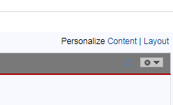

- A new window will open that shows different options that you can add to your page. In the section titled Human Resources System, click the check box next to My Employees Time, then click Save. (Note: your choices may look different from the screen print below due to access)
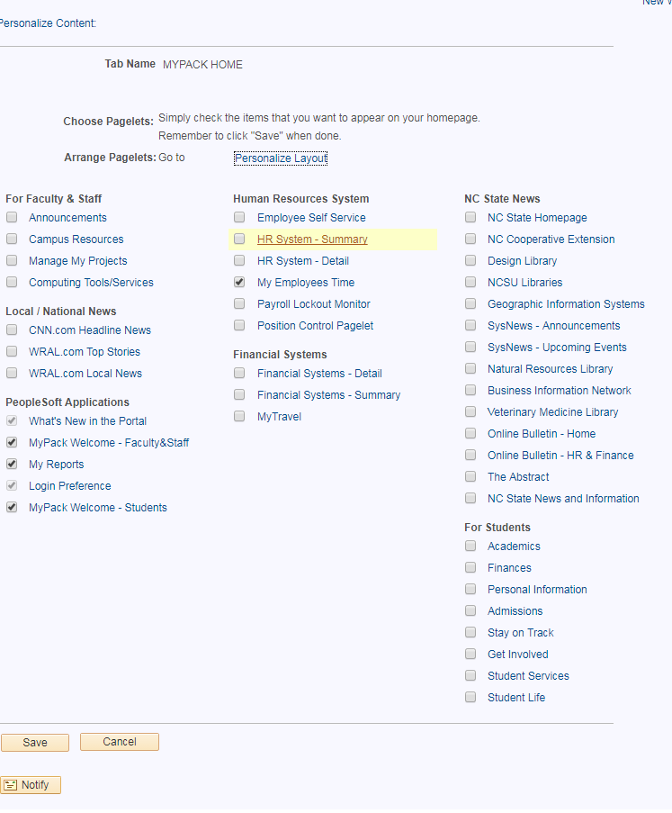

- Your MyPack Home Page will automatically update to show a new block that says My Employees Time.

