COUNTY HOLIDAYS AND CLOSURES
In an effort to improve our processes for employees, we have changed the way we will process county holidays and closures. Starting in June 2022, we will no longer be loading the county holidays into our system. This process is very labor intensive and the frequent changes by county government make it difficult to keep our records accurate.
With the new system, employees will enter leave requests for holidays and other office closures (think snowstorms, hurricanes, etc.) and supervisors will have the ability to approve them like all other leave requests.
All employees who receive a paycheck from NC State will be required to do this process. This includes COSS, Agents, and CEDs. Supervisors will need to monitor the holiday entries to make sure they are correct. For example, if you know your county is closed on Monday, July 4th and an employee enters the holiday as Thursday, July 7th, you should deny the request and ask them to fix it. This process can also be used for county floating holidays (if your county has those). Some counties allow employees to take their birthday off that should be considered a County Holiday.
Below you will see screen shots on how the entries are made.
First, log into MyPack Portal and navigate to Employee Self Service. Once here, click on the Wolftime icon:
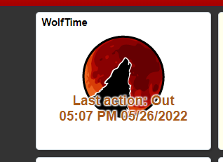

Once you are in Wolftime, select the option on the left to Request an Absence. When the window opens up, change the toggle at the top for “Include FML/FIL/PPL/Workers Comp Absences” to Yes. This step is needed to see the Absence name that you need, it is protected here for County Extension employees because the rest of campus does not have this feature.

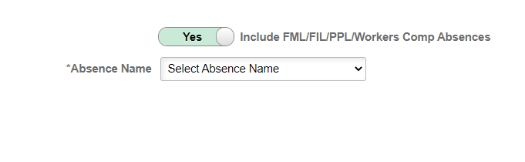
After you change the toggle to yes, you should see a list that looks something like this under Absence Name:
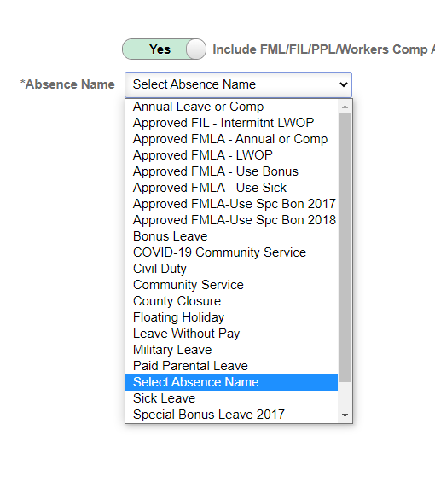
In the drop down list, pick the “County Closure” option (noted by the green arrow above. That will allow you to select your “Reason” in this category your two reason options are County Closure and County Holiday. Remember, County Holiday should only be used for actual County/Tribal Holidays; you need to confirm those with your County/Tribal government. The County Closure option can be used for other reasons such as adverse weather or other closures. Once you select your reason, the rest of the entry is like any other leave request.

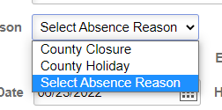

Enter your dates. All holidays need to be used in full day amounts. Closures can be used in partial days if the county had a late opening due to ice or other issues. Enter comments as to why you are using this action/reason and submit it to your supervisor for approval.

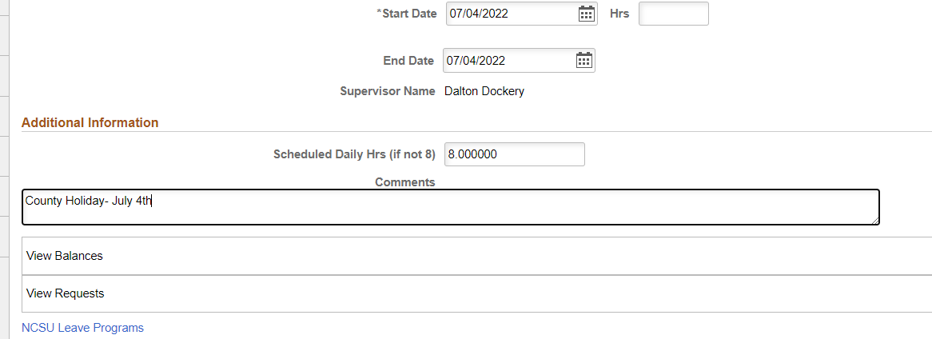

The Extension HR office will be auditing leave records on a regular basis. It is each employee’s responsibility to enter leave for holidays and closures, and it is the supervisor’s responsibility to review and approve them on a regular basis.

